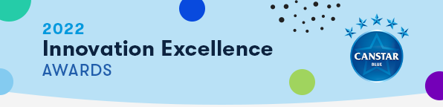
Submission Instructions
- Complete the Award Submission Form.
  - All submissions must be accompanied by a completed Submission Form (see below).
  - Only one submission form is required per innovation.
  - A new submission form is only required for additional innovations, i.e., a company is submitting more than one innovation to the Awards.
- Complete your submission using the questions provided in the Award Submission Form below (4 pages or less is recommended).
- Include/attach any relevant supporting materials such as a short video, statistics or images that demonstrate the utilization and impact of your innovation.
- Email submission to updates@canstar.com.au
  - Please use the following subject line format:
Canstar Blue Innovation Award {Insert Product/Service Name}
- Submission deadline is Friday 11th February 2022.
- Please note: The Judges’ decision is final, and no correspondence will be entered into.

Contact
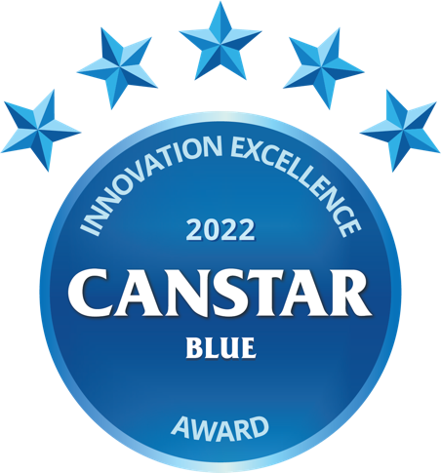
For further information on the Awards or the submission process, please contact:

Erin Jackson  Primary Analyst | Melissa Martens  Team Lead

Awards Submission Form

Please complete the following and include in your submission (4 pages or less recommended).

AWARD DETAILS

Please indicate (X) the Award/s in the 1st column that you would like the innovation to be considered for below:
Innovation Excellence - Energy
Innovation Excellence - Telecommunications

CONTACT INFORMATION
Institution:
Product/Service Name:
Launch Date of Innovation:
Contact Person:
Contact Details:

Questionnaire
- Initiative Product/Service Overview (word limit: 200)
Please provide an overview of the product, service, or feature offering.

- Outline the target market and highlight the pain points/needs that are being addressed by your innovation.
Who is the primary target market and what are their key pain points or needs that the innovation addresses?

- Demonstrate how the innovation addresses the target market’s pain points/needs.
How does the innovation address/solve these pain points, have a positive impact on people’s lives or empower consumers?

- Provide evidence that demonstrates the innovation’s utilisation and impact.
Utilisation and impact refers to how customers use or engage with the product or service, or how the innovation reshapes the industry, competition, and consumer behavior. Examples of supporting evidence might include customer growth %, customer engagement insights, number of customers or customer feedback (e.g., customer satisfaction or NPS).

- Demonstrate how this product/service differs to what is currently available in the market from current providers.
What makes this product or service unique, new and/or different to current market options domestically and internationally? How different are the features to those already available? Does it open a new market?

- Outline any conditions or costs that are attached to the product or service.
If applicable, what are the ongoing costs incurred for customers? Are there any upfront or exit fees?

