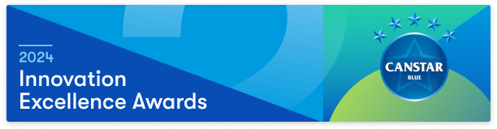

Submission Instructions
- Complete the Award Submission Form.
  - All submissions must be accompanied by a completed submission form.
  - One form is required per product, service or initiative innovation submitted for consideration in the awards. Please duplicate the submission form for multiple submissions.
- Include or link to in the submission form any relevant supporting materials such as a short video, data or images that support the submission.
- Email the submission form to blue.updates@canstar.com.au by 5pm AEST on February 2, 2024, using this subject line format: Innovation Award [Submission Name]

Please note:
- Canstar Blue will validate submission content against publicly available information and reserves the right to revoke any submission deemed to be false or misleading.
- The judges’ decision is final and no correspondence will be entered into.

Contact
For further information on the Awards or the submission process, contact blue.updates@canstar.com.au:

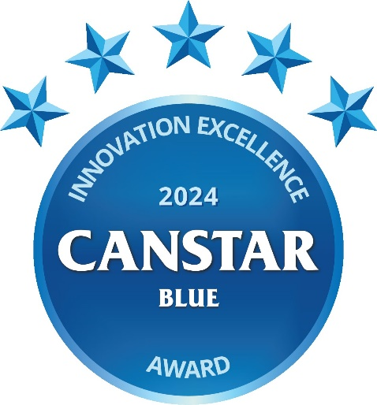

Awards Submission Form

Please complete the following and include in your submission (4 pages or fewer recommended). Submissions can be made in the form of a word document, PDF or presentation.

AWARD DETAILS

Please indicate (X) in the 1st column the category/categories that best describe your submission
Energy
Telecommunications
Appliances
Other

CONTACT INFORMATION
Company or Brand:
Product, Service or Initiative Name:
Launch/Release Date:
Contact Person:
Contact Details:

Questionnaire
1. Provide an overview of the product or service (word limit: 250)
Provide an overview of the product, service or initiative, including any conditions and/or associated costs.
2. Demonstrate how the innovation addresses the target market’s pain points/needs.
How does the product, service or initiative address the target market’s pain points, have a positive impact on consumers’ lives or empower consumers?
3. Demonstrate how this innovation differs from what is currently available in the market?
What makes this product, service or initiative new and unique when compared to current market options available domestically and internationally? How different are the features to those already available?
4. Provide evidence that demonstrates the innovation’s utilisation and impact.
Utilisation and impact refer to how customers use or engage with the product, service or initiative. It can also include how the offering reshapes the sector/industry, competition or consumer behaviour. Examples of supporting evidence might include a video tutorial, sales insights or growth, customer satisfaction or any other supporting data/insights.
Note: Any ‘social good’, ESG or sustainability metrics included in the submission must be adequately substantiated for these metrics to be considered in judging.

